Exercise 12: React Hook (useState)

Objectives and Outcomes

useState is a React hook that allows you to add state to functional components in React. By using the useState hook, you can easily introduce and manage state in your functional components, allowing them to maintain and update data over time.

Exercises

1. Creating a simple counter component that increments a number every time a button is clicked.

Expectations:

* Every time the button is clicked, the number should increment by 1
* Display the current number state in the text element

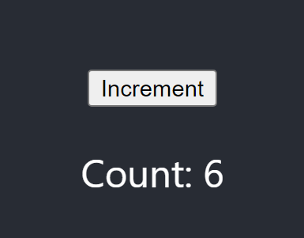

1. Controlled Input Field

Create an input field component that allows a user to type in text and displays the text in real-time.

Every time the user types something in the input field, the text should update in the text element

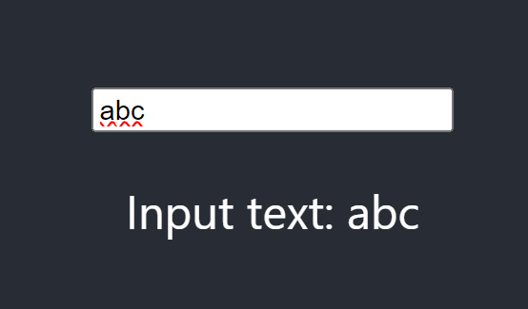

1. Toggle Visibility

Creating a component that toggles the visibility of a piece of text when a button is clicked. Expectations:

* Initially, the text should be hidden and there is only show button
* When the button is clicked, the text should become visible and hide button is changed

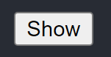

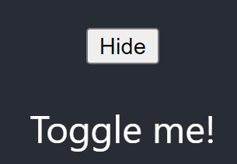

1. Todo List

Creating a simple Todo List component that allows users to add new items to the list and delete items once they are completed. The Todo List should have the following features:

* An input field for adding new todo items
* A button to submit the new todo item
* Display the list of todo items

A delete button next to each todo item to remove it from the list

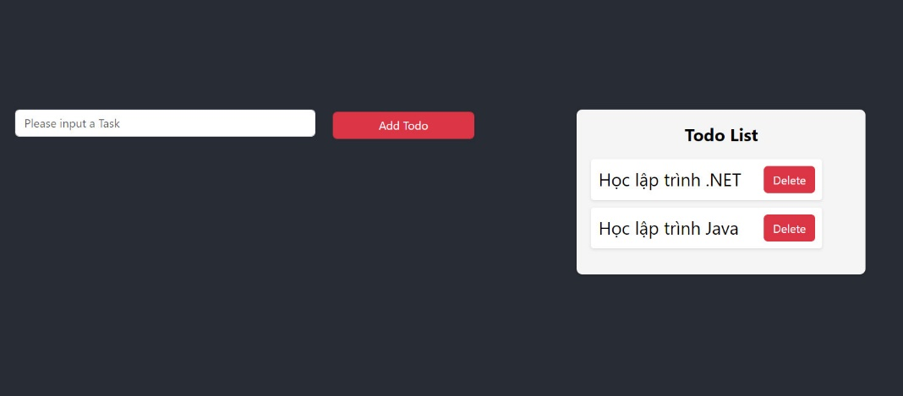

1. Color Switcher

Creating a simple Color Switcher component that allows users to change the background color of a div by selecting a color from a dropdown list.

Expectations:

* Create a dropdown list with a few color options (e.g., red, blue, green, yellow)

When a color is selected from the dropdown, the background color of the div should change to the selected color

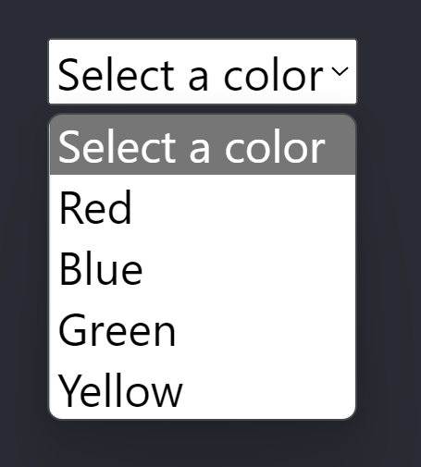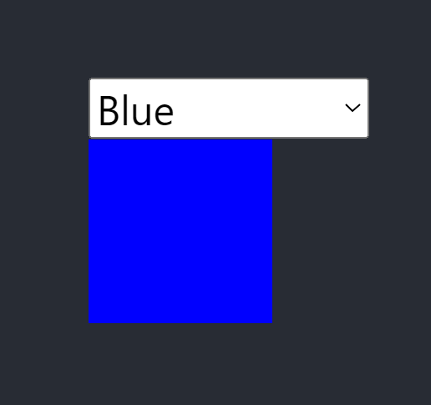

1. Search Filter

Creating a simple Search Filter component that allows users to filter a list of items based on their search input.

Expectations:

* Create an input field for users to type in their search query
* Display the list of items and filter them based on the user's search input

1. Drag and Drop List

Creating a simple Drag and Drop List component that allows users to reorder a list of items by dragging and dropping them. The Drag and Drop List should have the following features:

* Display the list of items
* Allow users to drag and drop items to reorder the list

Hint:

Need to manage two pieces of state: items and draggingItem. Items represents the current order of the list items, while draggingItem tracks the index of the item being dragged need to handle three drag-and-drop events to enable list reordering:

* onDragStart: Triggered when the user starts dragging an item. We define the handleDragStart function that takes the index of the dragged item and updates the draggingItem state
* onDragEnd: Triggered when the user drops the dragged item. We define the handleDragEnd function that resets the draggingItem state to null render the list items with the draggable attribute and attach the appropriate event handlers for the drag events

Can use splice method in ES6

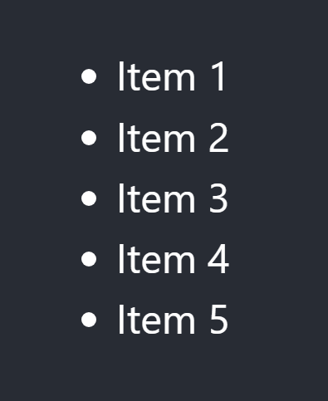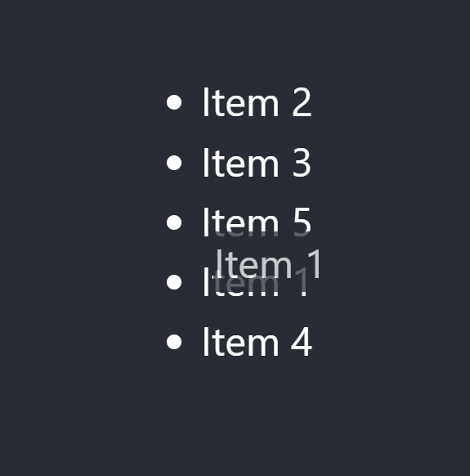

Conclusion

After learning about useState in React Hook, you should now have a good understanding of how to add and manage state in functional components